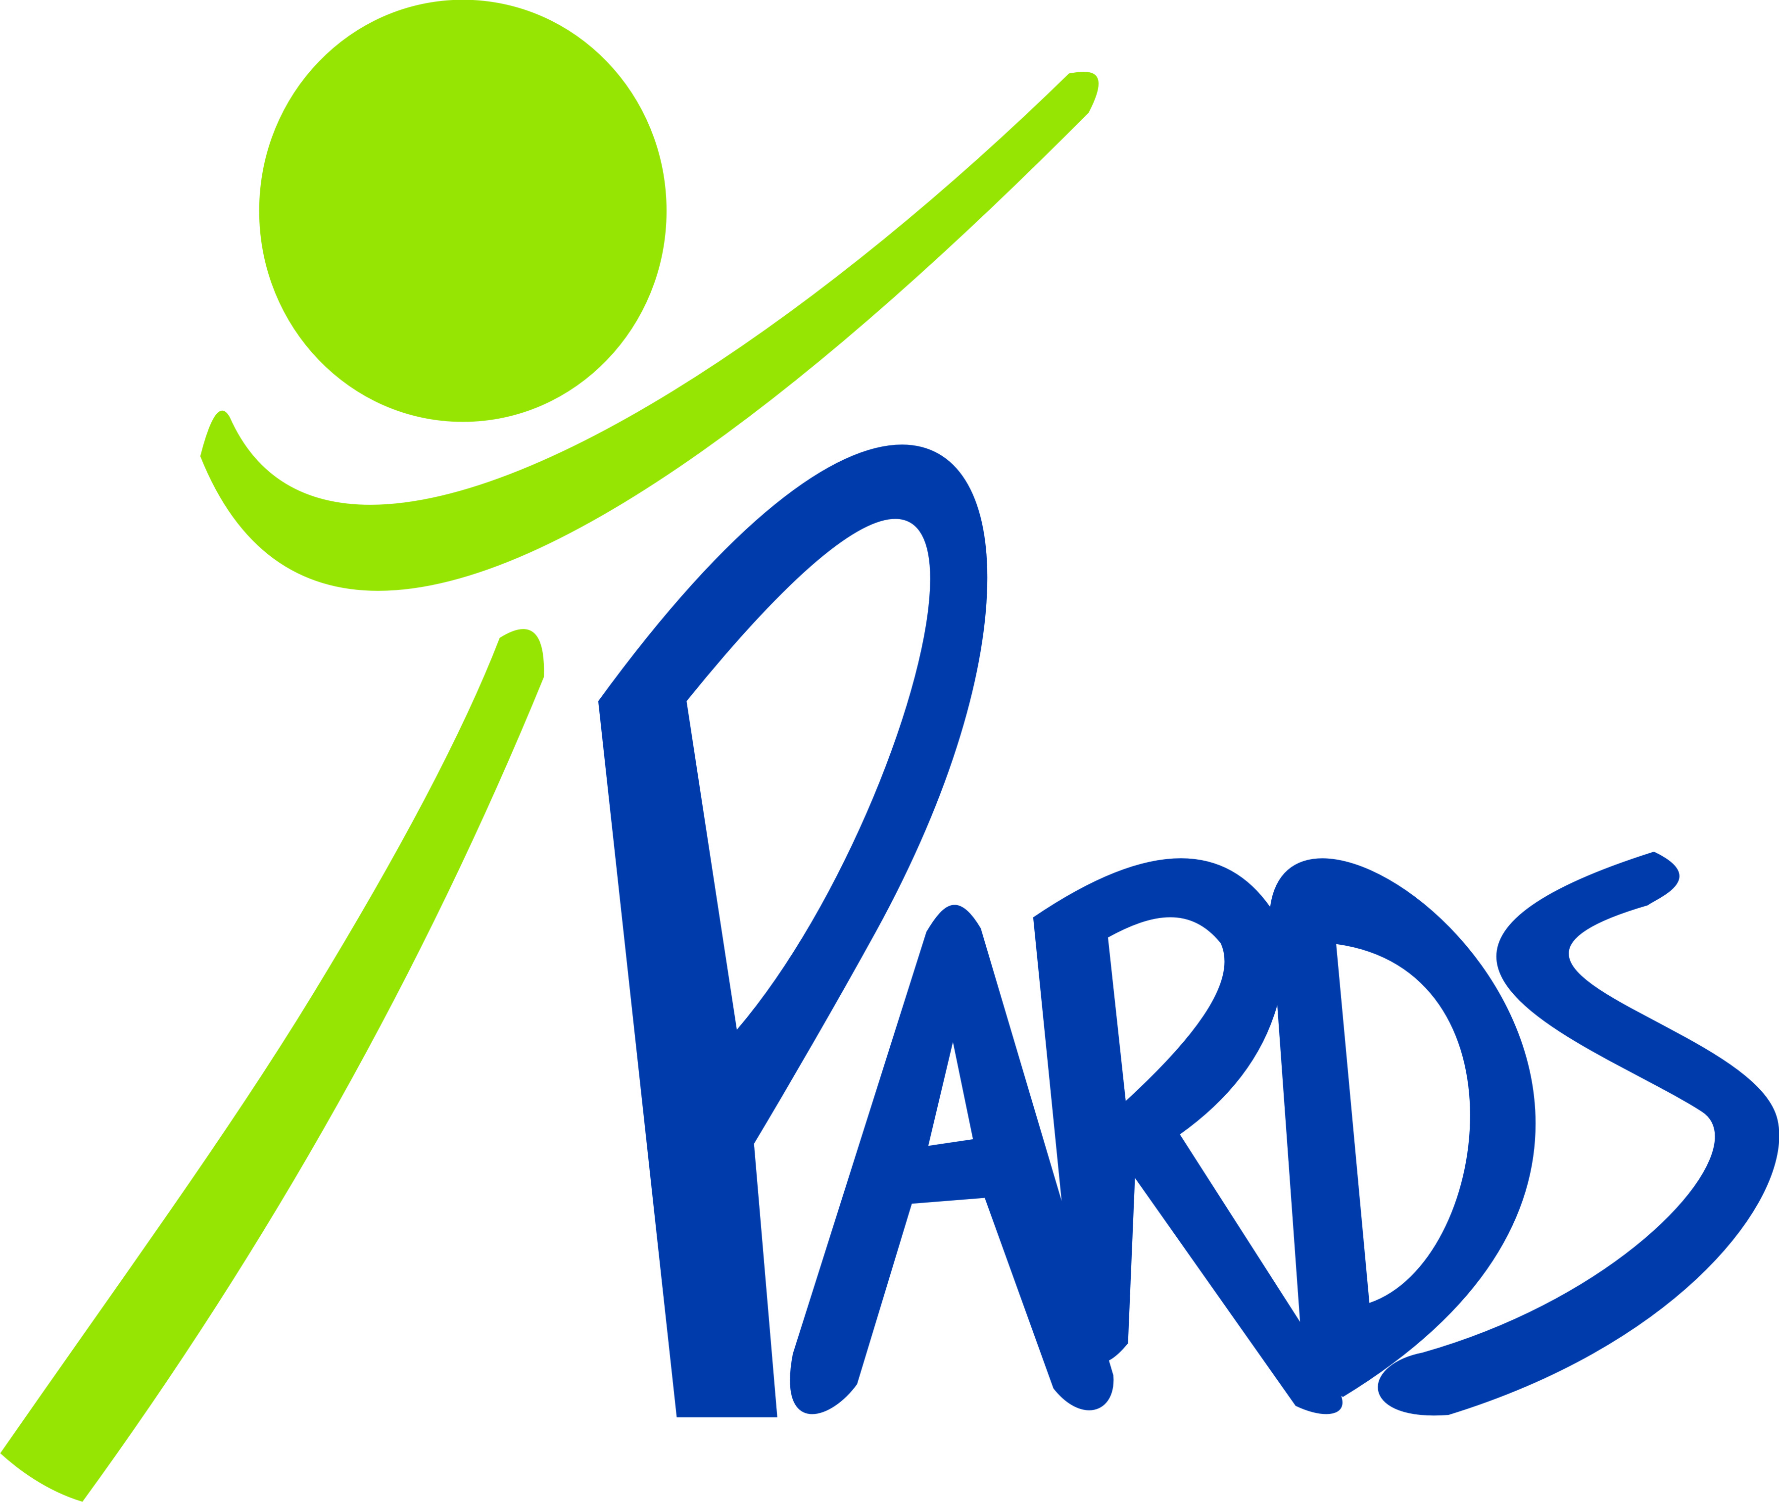
Indoor Pool Rental

Reserve a party at our heated pool for your special event.
(PARDS members will still be allowed to swim in designated areas of the pool during party)

Day: Every Sunday (Year-round) Time: 2:00 pm – 4:00 pm Fee: $200 (Flat Rate)
80 People maximum Includes 3 lanes/ramp area Lifeguard on Duty

Booking/Damage Deposit $100:
- Assures your date is reserved.
- Will be returned as long as the area is left clean and no damages have been incurred.
- A lifeguard will inspect the pool area at the end of your rental.
- You may claim your deposit one week after the event.
- If you cancel the event PARDS will keep the booking fee.
How to rent our facility:
- All rentals will be held Sunday between 2:00 pm to 4:00 pm. All guests must be out of the building by 4:30 pm.
- Ensure that the Sunday you want is at least two weeks away.
- Call or visit us to verify if the date is available.
- Fill out Rental Contract, payment can be made by check, money order, and credit or debit card. We do not accept cash.
- All reservations will be taken at the Front Desk Monday through Friday 9 am to 5 pm.
Food:
- You may bring food and beverages to accommodate the party.
- The selling of food/beverages will not be permitted.
- All food needs to be consumed in the designated area. No food on the pool deck.

Cool tips for a cool time:
Party host should arrive at 1:30 pm to setup. Eating and cutting of the cake will be done in designated area; don’t forget your knife, plates and eating utensils. Guests do not have to be members but they must adhere to all rules, polices and regulations. No more than 80 people will be allowed.

- Only USCG approved flotation devices will be allowed. No Arm Floaties!
- Life vests and life belts will be available free of charge.
- Proper swim attire must be worn by all guests that plan on entering the water.
- Tables & chairs will be provided.

Contact Information: (225) 664-8099 - 30372 Eden Church Road - Denham Springs, LA

PARDS Indoor Pool Rental Contract

Full Name: Today’s Date:

Address:_______________________________________________________________________

Phone #: (Mobile) (Work) (Home)

Sunday Rental Date: Type of Event:

Approximate # of Guests: __________________

To the fullest extent permitted by the Laws and Regulations, Renter shall indemnify, defend and hold harmless Owner and their consultants, agents and employees from and against all claims, damages losses and expenses, direct, indirect or consequential (including but not limited to fees and charges of engineers, architects, attorneys and other professionals and court and arbitrary costs) arising out of or resulting from the applicable performance, constructions, installation, and/or maintenance provided that any such claim, damage or loss or expense(a) is attributed to bodily injury, sickness, diseases or death, or to injury to or destruction of tangible property including the loss of use resulting there from and (b) is caused in whole or in part by any person or organization directly or indirectly employed by any of them to perform or furnish any of the work or anyone for whose acts any of them may be liable, regardless of whether or not it is caused in part by a party indemnified hereunder or arises by or is imposed by Law and Regulations regardless of the negligence of any such party.

ASSIGNABILITY: The Renter shall not make a sublease or any assignment of this rental agreement in whole or in part, without the prior written consent of the Owner.
Thus done, read and signed on this________day of_____________20_____.

By: _____________________________ __________________________
Owner Renter

Returned Check Fee: A $25.00 fee will be charged for any returned check. Initial ________

*Below For Office Only*

Deposit Date: __________ Amount:___________ Balance: ____________ Pmt Type:_________

Final Payment Date: _______________ Amount: _____________ Pmt Type: ________________

